‘All This Was Mission’ a journey to self-discovery
| FEBRUARY 05, 2021
BY ROXANNE ABRAMOWITZ
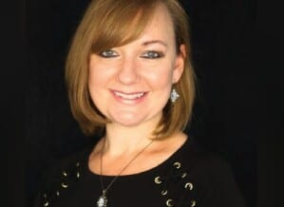
Cunningham
Connellsville author S.J. Cunningham hopes her first published novel will take readers on a spiritual journey to self-discovery.
“All This Was Mission” is available at Amazon and Barnes & Noble.
Cunningham said she has always been a reader and writer.
Cunningham is a Yough Senior High School graduate. She majored in English literature in college and received a master’s degree in the writing of fiction from Seton Hill University in Greensburg.
Originally from Westmoreland County, the family moved to Connellsville, where her children, Rachel, Noah and Adam Barczyk became Connellsville Area School District students.
Rachel and Noah have since graduated from high school, and Adam is in his senior year. Cunningham described the Connellsville area as a great place for her children to grow up.
The written word
“Writing has always been a part of what I do,” she said. “Books can transport you to another place and time, but more than that, they can impart wisdom through storytelling. And those words can offer a sanctuary or create a wake-up call in your life.”
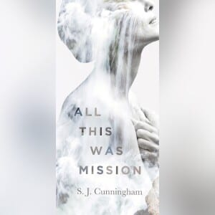

Cunningham said “All This Was Mission” follows the journey of Madeline, who has made mistakes in her life and paid dearly for them.
Madeline finds herself visiting mysterious Ashrama resort with a group of strangers, all with problems of their own.
The trinity of hosts appears to have an ulterior motive for their guests’ visit. Ashrama holds many secrets and is not what it seems. But neither is Madeline.
Cunningham said many women and others look back on parts of their lives and how they’ve lived it and think about how they could have done things differently.
She wanted to express those feelings.
This is not the first novel Cunningham has penned, having written several when her children were young.
None of those were published.
She has spent most of her career in the corporate world.
“Even though I wasn’t writing fiction, I still managed to make writing a major part of my career,” Cunningham said.
She has worked as a technical writer, then a professional communicator focused on executive communications, community outreach, crisis communications and large corporate initiatives.
“I’ve been lucky to be able to do what I love and get paid for it,” said Cunningham, who recently left her day job to focus on personal writing.
“The act of writing is raw and sometimes painful. Truths are revealed, and wounds reopened,” Cunningham said. “And once you get it down on paper, you’re expected to share your revelations with other people. Not just share it — actively market it.
“For an introvert like me, that’s really difficult.”
Cunningham said navigating the pandemic has been difficult for everyone.
“And I believe it’s been especially challenging for women as they’ve tried to work from home, or lost their jobs, and were expected to teach their children while ensuring that home life is running smoothly,” she said.
“It’s natural to sometimes wonder what this life is all about and perhaps question the current path.
“If my writing speaks to someone or can help just one person who needs to hear the words, then the act of writing and promoting will have been worth every second.”
Cunningham said the novel’s title is “an homage to German poet and philosopher Rainer Maria Rilke’s Duino Elegies, and part of a quote from the first Elegy, which references coming to terms with human existence.”
“All This Was Mission” was published by Koehler Books of Virginia Beach.
Cunningham said the process from writing to publication of “All This Was Mission” took about about nine months.
She is already working on two other novels.
“Chosen,” a post-apocalyptic novel, is in the writing stage.
“The Book of Grace” is a young adult novel. She just received the novel back from her editors and it should be out by summer.
She thanked her family and friends for their support, adding her children have been a source of inspiration.
Many people have preordered the novel and should be receiving it in the mail this week or next, Cunningham said.
“I’m excited, too,” Cunningham said. “It was really a fun project.”
“All This Was Mission” comprises about 170 pages. But it’s not a beach read, Cunningham said.
“It requires a little more,” she added.
The book is dedicated to Cunningham’s father, the late Stanley Cunningham, who passed along a love of reading to his daughter.
“He was always a big part of my life and I wish he could have seen this. I’m sure he is looking down and excited for me, too,” Cunningham said.
Her grandmother helped to forge her love of reading, too.
“My grandmother always got me books,” she said, starting with the likes of Nancy Drew and the Hardy Boys. As she got older, she was introduced to the likes of Jane Austin, George Eliot, Emily Bronte, and others, eventually moving on to such authors as Ann Taylor, where she enjoyed following the perspective on the female journey. She was also influenced by books on philsophy.
For information, go to www.sjcunningham.net or www.facebook.com/sjcunninghamwriter for updates.

